Notes on EastLong QA/QC for GLEON metab/catchment group

Jake Zwart; 2016-02-16

**QA/QC overview**

**METADATA**

*EastLong DO sensor depth* = 0.7 m.

Ave Elevation = 514 m

*windHeight* <- 2 m #height above lake at which wind speed is meaured

*timeStep* <- 10 #number of minutes between DO measurements

*lat =* 46.23657 #latitude of EastLong

**DO file**

No NA’s / missing data; no obvious anomalies

Range = 4- 8.6 mg L-1

**Wind speed file**

No NA’s / missing data; no obvious anomalies

Range = 0 – 6.49 m s-1

**PAR file**

No NA’s / missing data; no obvious anomalies

Range = 1.2 – 2553.7 umol m-2 s-1 (1.2 is the minimum measurement from Onset light sensors – occurs at night)

**Thermistor data file**

Some missing data (filled in as NA’s) at the beginning and end of the time series, but thermistor data is complete on dates for which there is DO obs.

No obvious anomalies

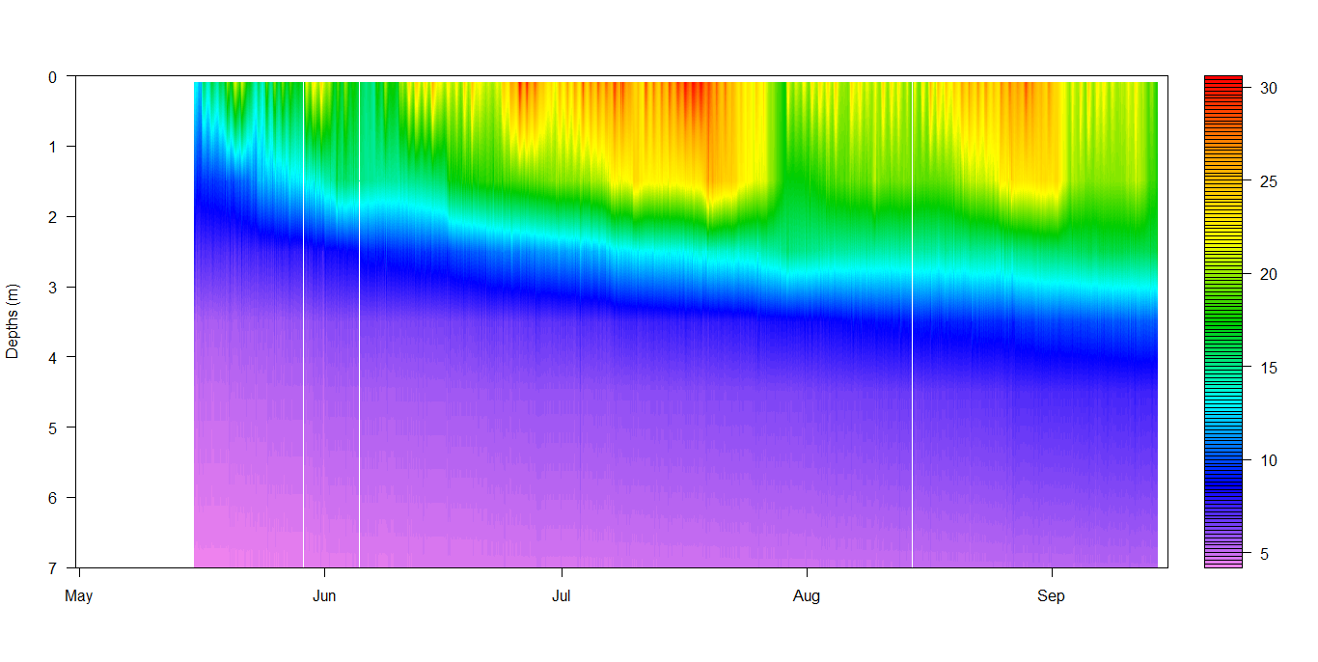

Heat map of thermistor profile